**BIRD WATCHING IN ANDAMAN**

The Andaman & Nicobar Islands is an unexplored island which is home for number of endemic birds on these islands.

**Birds to expect include:**

Some of the birds which are endemic to this islands are **Andaman Drongo, Andaman Bulbul, Andaman Shama, Andaman Woodpecker, Andaman Treepie, Andaman Serpent Eagle, Andaman Flowerpecker, White-headed Starling, Collared Kingfisher, Pacific Reef Egret, Vernal Hanging Parrot, Olive-backed Sunbird, Spot-breasted Woodpecker, Yellow Bittern , Andaman Crake , Slaty-breasted Rail, Andaman Cuckoo-Dove, Andamans Masked Owl, Andaman Scops-Owl, Andaman Boobook, Hume's Boobook, Andaman Nightjar, Andaman Shama**

**Places to Visit**

**Mount Harriet**

A blanket of eye-pleasing greenery is the first sight that greets you when you begin the journey to explore the many facets of Mount Harriet National Park. Perched atop Mount Harriet peak (1,257 ft) the third [highest peak](https://wildlifezones.com/highest-peaks-in-india-that-can-take-your-breath-away/) of Andaman and Nicobar archipelago, the park is spread over 46.62 sq km. The national park is named after Harriet C. Tyler, wife of British army officer Robert Christopher Tytler who was also a nature lover and a photographer. With the calm Andaman Sea in the backdrop, the entrancing beauty of the lush evergreen forests grows manifold. Mount Harriet National Park is a perfect place to spend some ‘me’ time in nature’s midst. With almost 90 distinct and rare bird species in the forest, Mount Harriet National Park is a bird watchers paradise. Birdlife International recognizes the park as one of the Important Bird Areas. Some of the birds found in the park are Andaman serpent-eagle, Andaman wood pigeon, Andaman hawk-owl and Andaman cuckoo-dove. Andaman wood pigeon is designated as the state bird of Andaman and Nicobar Islands.

**SippiGhat**

Sippighat Village is about 13 km away from Port Blair. Prior to 2004 Tsunami, Sippghat had paddy fields. Post-Tsunami it started brimming with bird population consisting of Brown Hawk owl, collared kingfisher, Orange headed thrush, Andaman Hawked Owl, Crested Serpent eagle, and White bellied sea eagle and a lot more.

**ChidiyaTapu**

As the name suggests, ChidiyaTapu - Chidiya means birds in Hindi language and Tapu refers to island is well-known amongst bird watchers. This one’s about 25 km away from port Blair. It is a home to countless beautiful birds such as Drongos, Hanging parrots, Emerald dove, green pigeons etc. Addition to this, you definitely can’t miss sunset when you’re in Chidiya Tapu.

**Havelock**

The largest island in the archipelago, Havelock Island is located 41 km away from Port Blair and stands between Peel Island and Neill Island. This island is named after Sir Henry Havelock, a British General. Apart from coral reefs and white sand beaches, it is densely populated with some endemic species of birds, for instance, Andaman barn owl, Andaman bulbul, Nicobar jungle flycatcher, Andaman flowerpecker**.** The island is a reservoir of mangroves, forests and variety of birds that are extinct from urban cities but are living a peaceful life here amidst the blue water and open sky. Morning in this island starts with the chirping of birds of various species and if you are a bird lover then you will get to watch many exotic birds on the island. Some of the species that cannot be missed are the endemic one’s like a green pigeon, emerald dove, hanging parrots, long-tailed parakeets and many other. These birds can be seen early in the morning and at the time of sunset.

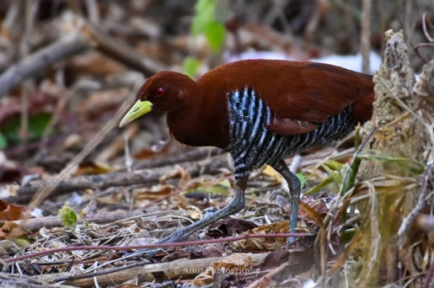 **ANDAMAN CRAKE**

**BLACK NAPED MONARCH** 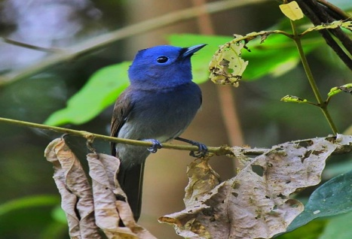

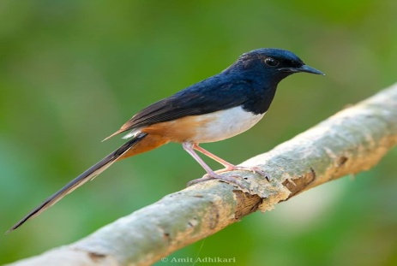 **ANDAMAN SHAMA**

**ANDAMAN FLOWERPECKER** 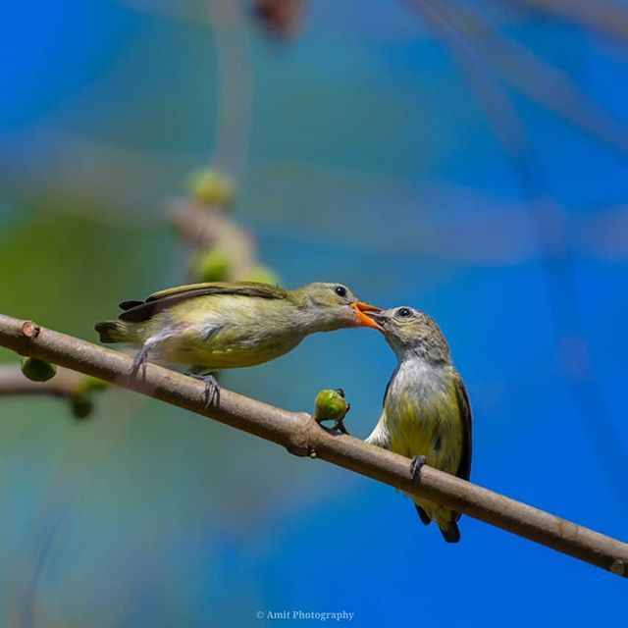

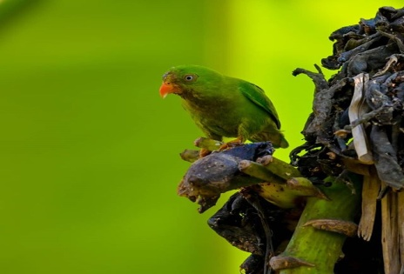 **LONG TAIL PARAKEET**

**EMERALD DOVE** 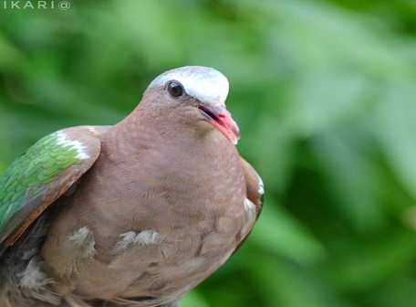

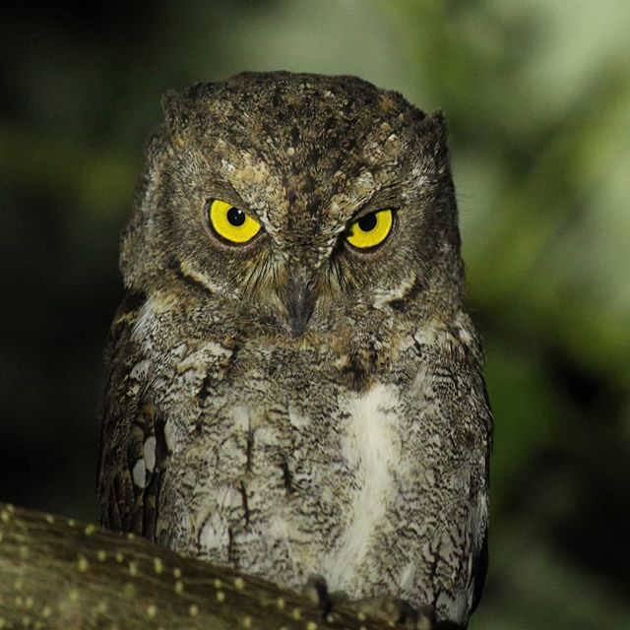 **WALDEN SCOOPS OWL**

Sample Itinerary for Birding

Day 1: Arrival transfer from Airport to Hotel Afternoon birding.   
Day 2: Morning and afternoon birding/N   
Day 3: Morning and afternoon birding/N   
Day 4: Morning and afternoon birding/N   
Day 5: Early departure transfer to airport in time for flight

**MAP OF ANDAMAN ISLAND WHERE BIRDING CAN BE DONE**

